User Manual Specification
Release Version -1.1
For
Meghna Solar Ltd.
Concern Topic: Financial Accounting

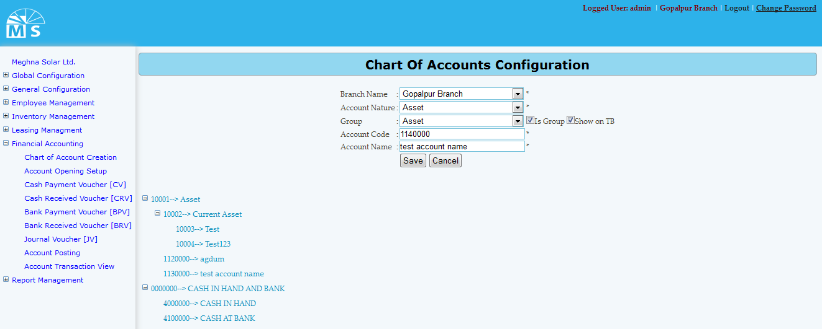

Chart of Accounts Configuration

Here user needs to select branch name, Account nature, and group from drop down list. Then user also needs to enter account code and account name to save chart of accounts configuration. Saved chart of accounts configuration will be visible below in tree diagram. If modification needed, user can click on the tree branch to modify information.

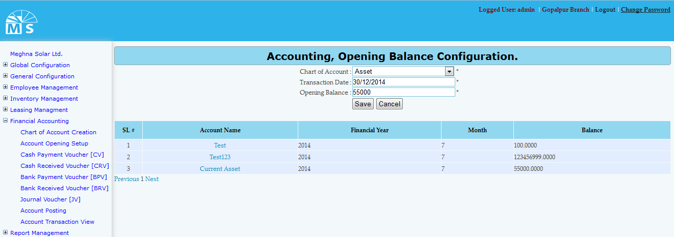

Account opening Setup

Here user needs to select chart of account from the drop down list then need to enter transaction date and opening balance to save opening balance info. After clicking save button information will be visible in the grid view. For any modification user need to click on account name in the grid view. After modifying information, user need to Press Update button. Then, modified information will be available in the grid view.
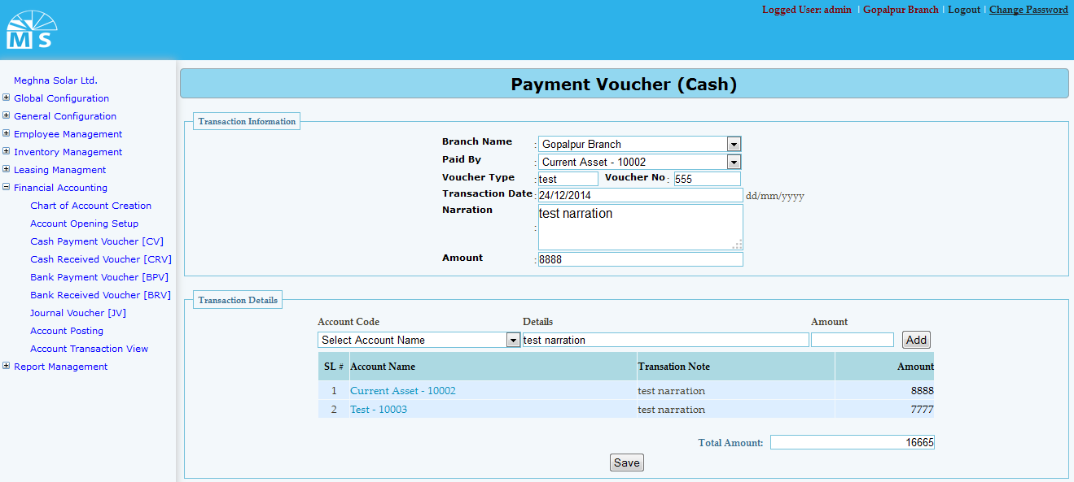

Payment Voucher (CV)

Here in Payment Voucher cash, there are two section. At first in transaction information section user needs to select branch name and paid by from drop down list. Then user also need to enter Voucher type, voucher no, transaction date, narration and ammount. Then in Second section named Transaction detail user need to add transaction detail information. For that user need to selelct accounr code from drop down and enter details and amount to add info. Added info will be visible in grid. Below Total amounrt will be shown. Then user need to click Save Button to save Payment Voucher (CV) information.
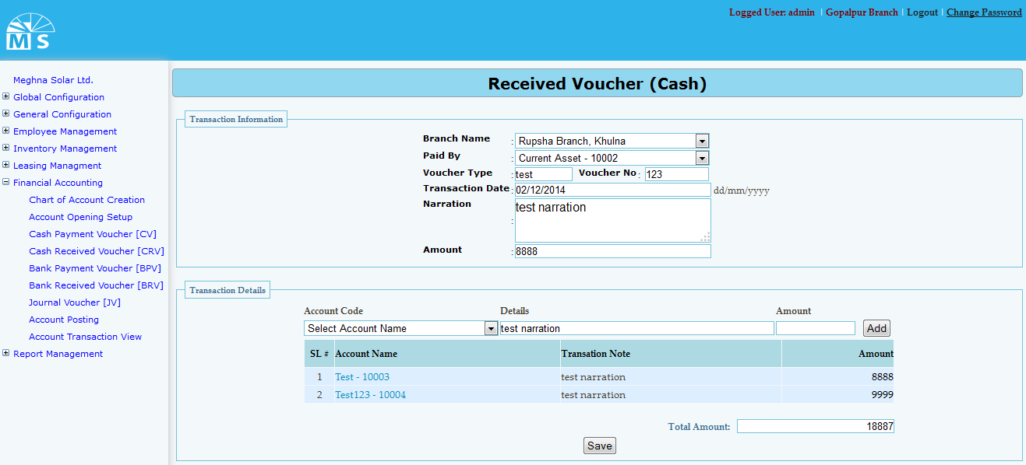

Cash Receive Voucher

Here in Cash receive voucher user needs to select branch name and paid by from drop down list. Then user also need to enter Voucher type, voucher no, transaction date, narration and ammount in first section. Then in Second section named Transaction detail user need to add transaction detail information. For that user need to selelct accounr code from drop down and enter details and amount to add info. Added info will be visible in grid. Below Total amounrt will be shown. Then user need to click Save Button to save Cash Receive Voucher information.
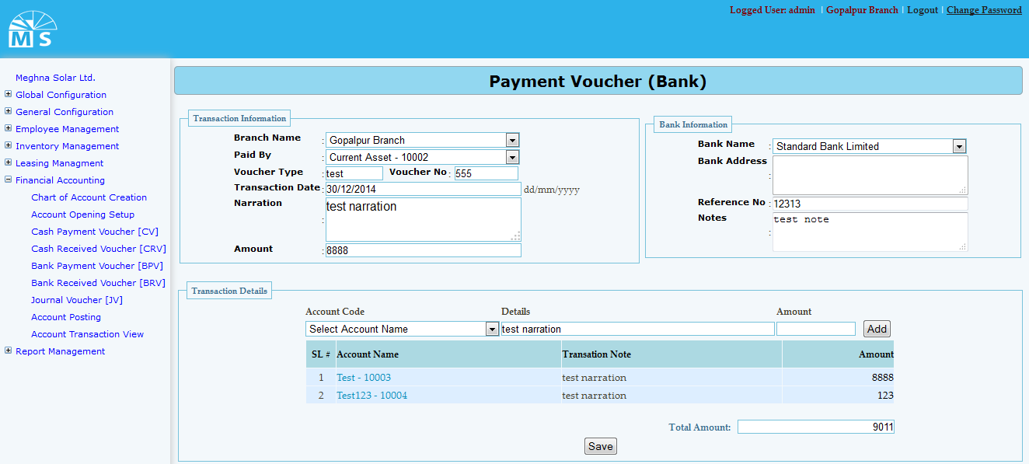

Bank Payment Voucher

Here we have three section Traction information, Bank information and transaction details. User user needs to select branch name and paid by from drop down list. Then user also need to enter Voucher type, voucher no, transaction date, narration and amount in first section. In second section user need to enter Bank information like Bank name, address, referrence no and note details.Then in Third section named Transaction detail user need to add transaction detail information. For that user need to selelct accounr code from drop down and enter details and amount to add info. Added info will be visible in grid. Below Total amounrt will be shown. Then user need to click Save Button to save Bank Receive Voucher information.
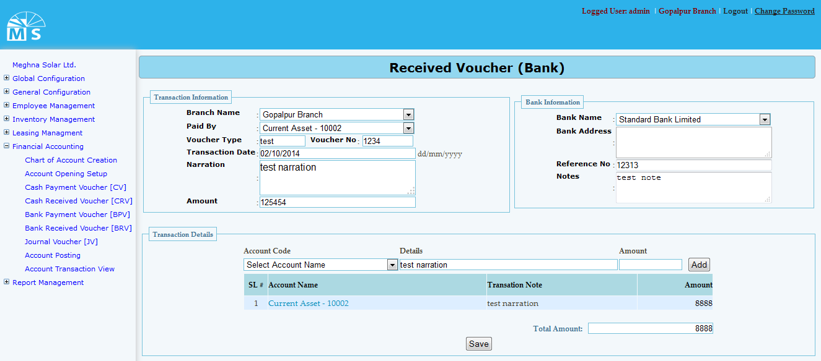

Bank Receive Voucher
Here we also have three sections. User user needs to select branch name and paid by from drop down list. Then user also need to enter Voucher type, voucher no, transaction date, narration and amount in first section. In second section user need to enter Bank information like Bank name, address, referrence no and note details.Then in Third section named Transaction detail user need selelct accounr code from drop down and enter details and amount to add info. Added info will be visible in grid. Below Total amounrt will be shown. Then user need to click Save Button to save Bank Receive Voucher information.
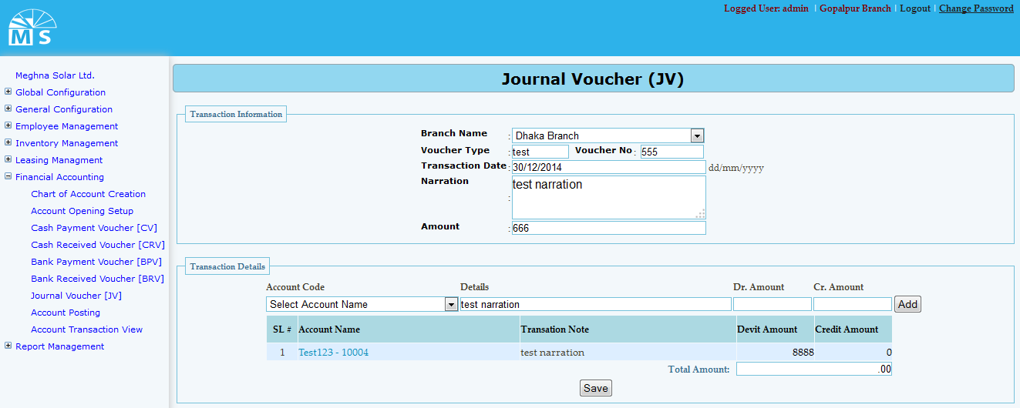

Journal Voucher

Here in Journal voucher user needs to select branch name from drop down list. Then user also need to enter Voucher type, voucher no, transaction date, narration and ammount in first section. Then in Second section named Transaction detail user need to add transaction detail information. For that user need to selelct accounr code from drop down list, enter details and amount to add info. Added info will be visible in grid. Below Total amounrt will be shown. Then user need to click Save Button to save Journal Voucher information.
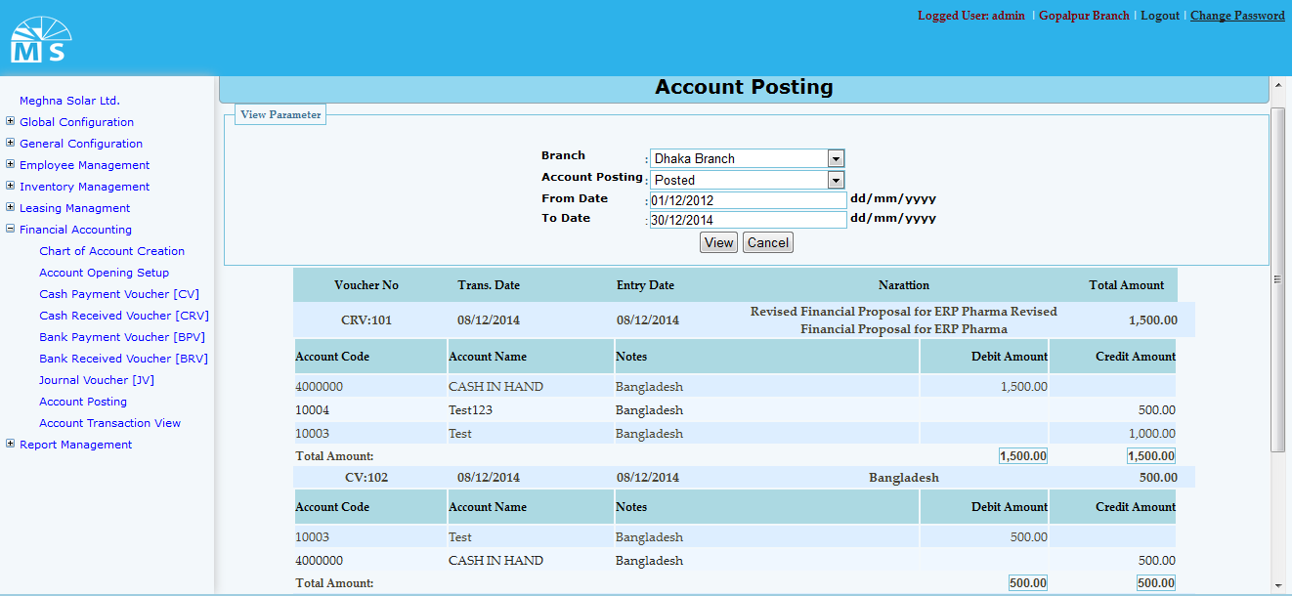

Account Posting
Here in Account Posting section user need to select branch and account posting from drop down list.Then user need to enter date range and click view button. After that account information will be visible in the grid view below.

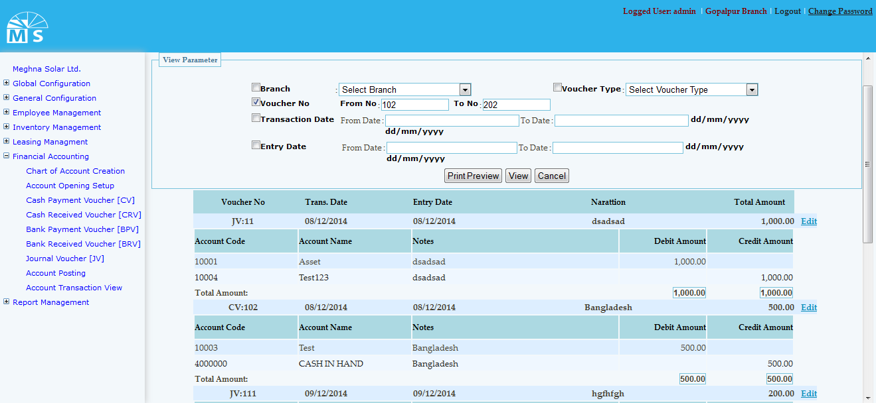

Account transaction view

Here in Account transaction view user can print, view voucher information by selecting different cryteria in view parameter section. The parameters are branch name, voucher type, voucher no, transaction date and entry date.

